Scan in Travel
Project Plan

By
Yirui Wang 542115509
Ruijuan Liu 542115508

Department of Software Engineering
College of Arts, Media and Technology
Chiang Mai University

Project Advisor

Yun Rim Park

Document History
Document Name | Version | Status | Date | Viewable | Editable | Responsible
Documents
Scan in Travel _Project Plan | Project Plan_V0.1 | Reviewed | 28/05/2014 | Yun Rim Park  Yirui Wang  Ruijuan Liu | Yirui Wang  Ruijuan Liu | Yirui Wang  Ruijuan Liu

Document Approved by

Yun Rim Park

Table of Contents

Chapter One | Introduction.......................…….…………………………..…5
1.1 Identification……………………......…......................……………..5
1.2 Project Scope.….…………..….....…...........................……………..5
1.3 Document Overview……………......…......................……………..6
1.4 Objectives………................…….......…......................……………..7
1.5 Work Products to be Develop............…...........................………….8
1.5.1 Deliverable.....................................……………………….....…8
1.6 Acronyms and Definitions............…................................…….......10
1.6.1 Acronyms.....................................……………………….....…10
1.6.2 Definitions....................................……………………….....…10

Chapter Two | Infrastructure….........................….…………………………12
2.1 Software Development Life Cycle……......................…….……….12
2.2 Development Tools.......………………...……......………...………13
2.3 Hardware and Material Resources .……....…......………...………14

Chapter Three | Management Procedures………..………………...……….15
3.1 Project Team Structure.....……...........................………....………..15
3.2 Monitoring and Controlling Mechanisms.......................…………..15
3.2.1 Project Meeting….………............……………………...….….15

Chapter Four | Quality Planning……........…….............…………..….……16
4.1Quality Standard……..………………………...…………….…......16
4.1.1 Basic Profile Guide Processes…........…..………………….…16
4.1.2 Project Management Process……........…………………….....17
4.1.3 Software Implementation Process…...….………………….....17

4.2 Reviews/Responsibility……..……………….....………………….17
4.3 Testing…….......……....................................………..…………….18
4.4 Quality Factors……..….................…………….………………….18

Chapter Five | Schedule and Milestones…………..………………………..20
5.1 Project Schedule……..………..……………...……………..…......20

Chapter Six | Software Configuration Management…....…………………..28
6.1 Software Configuration Management …………..……….…..….....28
6.2 Filename Format …………..……….….................................…......28
6.3 Change Management ……………….….................................…......28
6.4 Software Configuration Item Table ...….................................…......29

Chapter Seven | Risk Management……….….............……………………..30
7.1 Risk Management Process……..………..........……………..…......30
7.2 Risk Identification and Solutions...……...........……………..…......31

Chapter Eight |Reference……….….............…...............…………………..34

Chapter One | Introduction

1.1 Identification

“Scan in Travel” is an Android application that uses the built-in camera of a mobile phone to capture the image of one or more Chinese words, converts that image into text, and translates the word(s) into English. Tourists can understand the meaning of the word in text and listen to how it is pronounced in Chinese. “Scan in Travel” can use the built-in camera to capture the image of a Location name, and provide the maps and route of the place to help users get to the location. Moreover, the application can also provide Favorites and Word book to help tourists record their trip and help them easily return those Locations.
This project plan is the document for planning, scheduling activities and evaluating overall of the project so that the project will complete as successfully as possible in spite of all risks. The project plan is the plan before start project and when project start, project plan is used to tracking and control project follow the plan.

1.2 Project Scope

“Scan in Travel” is a mobile application which using Android OS. This application can help users solve the language problems during their travel in China. Users can get the meaning of Chinese word(s) by scanning it with the built-in camera of their mobile phone. And users can also get the map and route if the scanned name is the name of a Location in China. What is more, “Scan in Travel” can also help users remember where they have been. Users can record the attractive places into their Favorites.
The main features of “Scan in Travel” will be following:

Translation system
Users can translate Chinese word(s) and Location name(s) into English by scanning them with the built-in camera of their mobile phone. After viewing the English translation of the word(s), users can also select the text-to-speech function to listen to the pronunciation of the Chinese word(s). Moreover, users can edit the Chinese word(s) that are scanned to get new explanation in English.

Favorites system
Users can save Chinese words and their English translation to their own Word book. If users scan a Location name, they can also save the Location with its name, pictures, geometry information (i.e. latitude and longitude), and descriptions into their Favorites. Users can take the picture of the Location and write down their own description for it. Moreover, users can sort and search words in their own Word book and Locations in their Favorites.

Map system
Users can keep their own map of every Location that they saved. The system lets users see every saved Location on a map, and check the details of each Location. Besides, users can scan a Location name and find where it is located on a map. The system will guide users to get to the Location by providing a route on a map.

1.3 Document Overview
The purpose of the “Scan in Travel” Project Plan is to guide the project team members during the development of the project.
Progress Report Ⅰ：
Feature #1 Translation system
1.1: Users can scan Chinese words and Location names by using built-in camera.
1.2: Users can view the explanation (i.e. meaning, pronunciation) of the scanned word(s) in English.
1.3: Users can select Text-to-Speech to get the Chinese pronunciation of the word.
1.4: Users can edit the Chinese word(s)(or Location name(s)) that are scanned to get the new explanation in English.

Progress Report Ⅱ：
Feature #2 Map system
2.1: Users can view the Location on the map if the scanned word is the name of a Location.
2.2: Users can view all Locations from their own Favorites on the map.
2.3: Users can view the map that shows the route from the current position to a Location stored in Favorites.
2.4: Users can view the map that shows the route from the current position to the Location whose name is scanned.

Feature #3 Favorites system (Part 1)
3.1: Users can add the scanned Location with its name, pictures, geometry information (i.e. latitude and longitude), and descriptions into their Favorites.
3.2: Users can delete a Location from their own Favorites.
3.3: Users can view the Location information with name, pictures, geometry information (i.e. latitude and longitude), and descriptions in their Favorites.
3.4: Users can sort the Locations in Favorites by district name.
3.5: Users can sort the Locations in Favorites by date they are added.
3.6: Users can search Locations by keyword in their Favorites.
3.7: Users can select Text-To-Speech to get the pronunciation of the Location name in their Favorites.

Progress Report Ⅲ:
Feature #3 Favorites system (Part 2)
3.8: Users can add the scanned words into their own Word book.
3.9: Users can delete a word from their own Word book.
3.10: Users can view the Chinese words and related information in their own Word book.
3.11: Users can sort the words in their Word book by date when they are added.
3.12: Users can sort the words in their Word book alphabetically.
3.13: Users can search Chinese words in the Word book by their meaning in English.
3.14: Users can select Text-To-Speech to get the pronunciation of a Chinese word in their Word book.

1.4 Objectives
1. To develop a mobile application that helps tourists who come to visit China with the followings:
-- Lowering the language barriers when they travel in China.
-- Getting the translation of the Chinese word in an easier way by scanning the word rather than typing.
-- Getting the map of the location in China easily by scanning the Location name.
-- Remembering and learning Chinese words.
-- Reaching the destination more quickly.
-- Remembering and recalling the Locations where they have been to.
2. To develop a mobile application that allows users to use the services anytime while traveling in China as long as they are connected to the Internet (Some functions are also supported offline. E.g. Word Book).

3. To offer the features that provide more convenience to tourists compared to using other guide books or dictionaries:
-- Providing a dictionary, a map, and a personal note in one application, which helps tourists travel light.
-- Reducing manual text input.
-- Saving time for searching information.

1.5 Work Products to be Develop
1.5.1 Deliverable
No. | Deliverables/Release | Media | Copies | Date
1 | Project Proposal  · Scan in Travel _Project Proposal_V1.0  · Scan in Travel _Project Proposal_V1.1 | Document  Document | 3  1 | 04-03-2014  18-03-2014
2 | Progress report Ⅰ  · Scan in Travel _Project Plan_V1.0  · Scan in Travel _Software Requirement Specification_V1.0  · Scan in Travel _Software Design document_V1.0  · Scan in Travel _Test Plan_V1.0  · Scan in Travel _Unit Test_V1.0  · Scan in Travel _Traceability Record_V1.0  · Scan in Travel _Executive Summary ProgressⅠ_V1.0  · Scan in Travel _Software ProgressⅠ_V1.0 | Document  Document  Document  Document  Document  Document  Document  Source Code | 3  3  3  3  3  3  3  1 | 28-05-2014
3 | Progress report Ⅱ  · Scan in Travel _Project Plan_V2.0  · Scan in Travel _Software Requirement Specification_V2.0  · Scan in Travel _Software Design document_V2.0  · Scan in Travel _Test Plan_V2.0  · Scan in Travel _Unit Test_V2.0  · Scan in Travel _Traceability Record_V2.0  · Scan in Travel _Executive Summary ProgressⅡ_V2.0  · Scan in Travel _Software ProgressⅡ_V2.0 | Document  Document  Document  Document  Document  Document  Document  Source Code | 3  3  3  3  3  3  3  1 | June
4 | Progress report Ⅲ  · Scan in Travel _Project Plan_V3.0  · Scan in Travel _Software Requirement Specification_V3.0  · Scan in Travel _Software Design document_V3.0  · Scan in Travel _Test Plan_V3.0  · Scan in Travel _Unit Test_V3.0  · Scan in Travel _Traceability Record_V3.0  · Scan in Travel _Project Status Report_V3.0  · Scan in Travel _Executive Summary _V3.0  · Scan in Travel _Software ProgressⅢ_V3.0 | Document  Document  Document  Document  Document  Document  Document  Document  Source Code | 3  3  3  3  3  3  3  3  1 | July
5 | Show Pro  · Scan in Travel _Software Demo_V2.0  · Scan in Travel _30 seconds video  · Scan in Travel _Poster | Demo  Video  Poster | 1  1  1 | September

1.6 Acronyms and Definitions
1.6.1 Acronyms
OCR Optical Character Recognition
VSE Very Small Entity
SMS Short Message Service
OS Operating System
SDK Software Development Kit
JDK Java Development Kit
API Application Programming Interface
JSON JavaScript Object Notation
XML Extensible Markup Language

1.6.2 Definitions
Project Plan Project plan is part of project management, which relates to the use of schedules such as Gantt charts to plan and subsequently report progress within the project environment.

Risk An uncertain event or condition that, if it occurs, has a positive or negative effect on a project’s objectives. It is a function of the probability of occurrence of a given threat’s occurrence.[1]

Risk Management Risk management is a software engineering practice with processes, methods, and tools for managing risks in a project. It provides a disciplined environment for proactive decision-making to assess continuously what can go wrong; determine what risks are important to deal with; and implement actions to deal with those risks.[2]

Traceability In software development, the term traceability (or Requirements Traceability) refers to the ability to link product requirements back to stakeholders' rationales and forward to corresponding design artifacts, code, and test cases.[3]

Unit Test In computer programming, unit testing is a software testing method by which individual units of source code, sets of one or more computer program modules together with associated control data, usage procedures, and operating procedures are tested to determine if they are fit for use.^{[1]} Intuitively, one can view a unit as the smallest testable part of an application.[4]

Configuration Item Component of an information technology (IT) structure or system under the control of configuration management.[5]

Chapter Two | Infrastructure
2.1 Software Development Life Cycle
Incremental delivery is a combination of waterfall model and evolutionary development. It is a method for developing a system through repeated cycles in smaller portions (increments), allowing developers to make use of what was learned during the previous parts in the development, and also a quick comment back from users when exposing one increment to them. Key steps in the process start with a simple implementation of a subset of the software requirements and incrementally enhance the evolving versions until the full system is implemented. Specification, development, and validation activities are interleaved with rapid feedback cross activities.
Scan in Travel uses Incremental Delivery Process for development. Because in the development, there are several progresses to separate the whole system. Each progress is considered as an increment to complete a sub-set of the system functionality. The allocation of services to increments depends on the service priority which is identified by customers, with the highest-priority services implemented and delivered first. System is delivered in a number of increments. Each delivery is usable and working but has only partial functionality, and furthermore, each delivery is the same as previous one but with some new functionality. The final delivery is the full system. We use Incremental Delivery Process to fulfill and change the software with its documents. Moreover, we can get a quicker feedback from stakeholders when we deliver each completed increment.
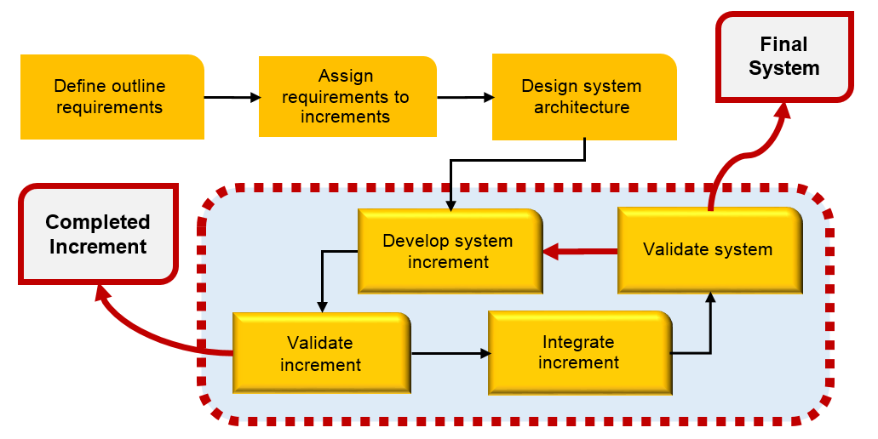
Figure 1: Incremental Delivery Process Model

2.2 Development Tools
• Eclipse
Eclipse is an open source, Java-based extensible development platform. For itself, it is just a framework and a set of services. It is used to build the development environment through plug-in components. But Eclipse comes with a standard plug-ins, including the Java development tools (Java Development Kit, JDK).

• ADT Plugin for Eclipse
Android Development Tools (ADT) is a plugin for the Eclipse IDE that is designed to give you a powerful, integrated environment in which to build Android applications. ADT extends the capabilities of Eclipse to let you quickly set up new Android projects, create an application UI, add packages based on the Android Framework API, debug your applications using the Android SDK tools, and even export signed (or unsigned) .apk files in order to distribute your application.[6]
• Tesseract-ocr
SQLite is a lightweight database. It is an embedded database engine. Nowadays, there are many embedded software system that use SQLite. It takes lower resources, for an embedded device, we only need a little memory. What’s more, it supports Android/ Windows/ Linux/ Unix operating systems, and it can be combined with many programming languages, such as C#, PHP, Java and etc. And the source code for SQLite is in the public domain.

• Microsoft translator API
Microsoft Translator provides a powerful set of web service APIs for developers to use its Machine Translation technology in their own applications, services or web sites. Microsoft Translator API can be invoked in variable ways, including an HTTP REST Service, an AJAX-callable service and a SOAP Web Service.

• Google Maps API
Google Maps API is a programming API that Google provides to developers. It allows developers to embed data of Google Maps into their web or application. And it helps developers provide the location services to users. In addition, Google Maps API not only helps developers to embed maps into their application, but also allows developers use JavaScript to expand their applications.

• SQLite
SQLite is a lightweight database. It is an embedded database engine. Nowadays, there are many embedded software system that use SQLite. It takes lower resources, for an embedded device, we only need a little memory. What’s more, it supports Android/ Windows/ Linux/ Unix operating systems, and it can be combined with many programming languages, such as C#, PHP, Java and etc.

• JSON
JSON is a lightweight data interchange format. It is based on a subset of JavaScript. JSON can covert a set of data represented in JavaScript Object into string. Then the string can be transferred between functions easily, for instance, from the Web client to server in asynchronous application.

2.3 Hardware and Material Resources
• Laptops
-- ASUS K43E
Processor: Intel(R) Core(TM) i5-2410M CPU @ 2.30GHz
Memory: 6.00 GB
Graphics: Intel(R) HD Graphics 3000
Operating System: Window 7 Home Basic

-- Dell Inspiron M4010
Processor: AMD Athlon(tm) ⅡP360 Dual-Core Processor @ 2.30 GHz
Memory: 6.00 GB
Graphics: ATI Mobility Radeon HD 5430
Operating System: Windows 7 Ultimate

• Internet
• Mobile phone: Android Operating System
-- Samsung GT-I9100G
CPU: ARMv7 Processor rev 3 (v7I) Dual-core @ 1.2 GHz
Memory: 1.97 GB
Operating System: Android OS version 4.0.4

• Repository: GitHub

Chapter Three | Management Procedures

3.1 Project Team Structure

Participants | Activities
Yirui Wang  Ruijuan Liu | Feasibility Study
Yirui Wang  Ruijuan Liu | Project Proposal
Yirui Wang  Ruijuan Liu | Project Requirements
Yirui Wang  Ruijuan Liu | Project Plan
Yirui Wang  Ruijuan Liu | Software Architectural Design
Yirui Wang  Ruijuan Liu | Software Detailed Design
Yirui Wang  Ruijuan Liu | Implementation
Yirui Wang  Ruijuan Liu | Testing
Yirui Wang  Ruijuan Liu | Review

3.2 Monitoring and Controlling Mechanisms
3.2.1 Project Meeting

Participants | Roles
Yirui Wang | Development team member
Ruijuan Liu | Development team member
Yun Rim Park | Project advisor

Chapter Four | Quality Planning

4.1 Quality Standard
• ISO 29110 for Very Small Entity (VSE)
ISO 29110 is a software processes and guidelines for very small entities. A very small entity is mean an enterprise, organization, department or project having up to 25 people. The guide are based on subsets of appropriate standards elements, referred to as VSE profiles. The purpose of a VSE profile is to define a subset of ISO/IEC standards relevant to the VSE.

4.1.1 Basic Profile Guide Processes
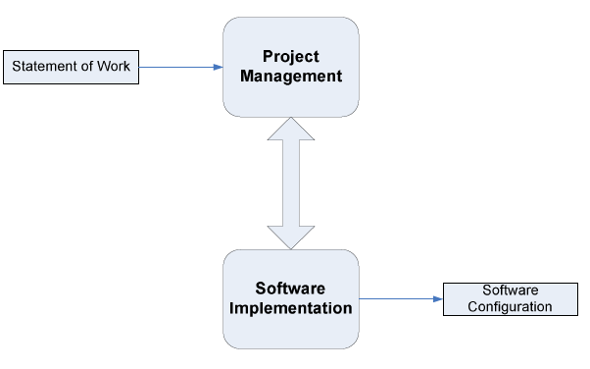

Figure 2: Basic Profile Guide Process

Project Management (PM) process uses the customer’s statement of work to elaborate the project plan. The PM project assessment and control tasks compare the project progress against the project plan and actions are taken to eliminate deviations or incorporate changes to the project plan. The PM project closure activity delivers the software configuration, produced by SI, and gets the customer’s acceptance to formalize the end of the project. A project repository is established to save the work products and to control its versions during the project.
The execution of the Software Implementation (SI) process is driven by the project plan. SI process starts with an initiation activity of the project plan review. Project plan will guide the execution of the software requirements analysis, software architectural and detailed design, software construction, and software integration and test, and product delivery activities.
4.1.2 Project Management Process
The purpose of the project management process is to establish and carry out in a systematic way the tasks of the software implementation project, which allows complying with the project’s objectives in the expected quality, time and cost.
Selected processes
4.1.2.1 Project planning process
4.1.2.2 Project plan execution process
4.1.2.3 Project assessment and control process
4.1.2.4 Project closure process

4.1.3 Software Implementation Process
The purpose of the software implementation process is the systematic performance of the analysis, design, construction, integration and tests activities for new or modified software products according to the specified requirement.
Selected processes
4.1.3.1 Software implementation initiation process
4.1.3.2 Software requirement analysis process
4.1.3.3 Software architectural and detailed design process
4.1.3.4 Software construction process
4.1.3.5 Software integration and test process
4.1.3.6 Software delivery process

4.2 Reviews/Responsibility
Stage Exit Review
No. | Stage | Review Item | Responsibility
1 | Requirement gathering | Project Proposal | Yirui Wang, Ruijuan Liu, Yun Rim Park
2 | Project Planning | Project Plan | Yirui Wang, Ruijuan Liu, Yun Rim Park
3 | Requirement Analysis and Specification | Software Requirement Specification | Yirui Wang, Ruijuan Liu, Yun Rim Park
4 | Architecture and Detailed Design | Software Design Document | Yirui Wang, Ruijuan Liu, Yun Rim Park
5 | Software Implementation | Code | Yirui Wang, Ruijuan Liu, Yun Rim Park
6 | Software Testing | Software Testing Documents | Yirui Wang, Ruijuan Liu, Yun Rim Park
7 | Project Monitoring and Control | Traceability Record | Yirui Wang, Ruijuan Liu, Yun Rim Park

4.3 Testing

No. | Test | Responsibility
1 | Unit Testing | Yirui Wang, Ruijuan Liu
2 | System Testing | Yirui Wang, Ruijuan Liu

4.4 Quality Factors

No. | User Requirement Specification | Related Quality Factor
URS-01 | Users can scan Chinese words and Location names by using built-in camera. | Correctness, Integrity, Reliability, Testability, Usability, Efficiency
URS-02 | Users can view the explanation (i.e. meaning, pronunciation) of the scanned word in English. | Correctness, Integrity, Reliability, Testability, Usability, Efficiency
URS-03 | Users can select Text-to-Speech to get the Chinese pronunciation of the word. | Correctness, Integrity, Reliability, Testability, Usability, Efficiency
URS-04 | Users can edit the Chinese word(s)(or Location name(s)) that are scanned to get the new explanation in English. | Correctness, Integrity, Reliability, Testability, Usability, Efficiency
URS-05 | Users can view the Location on the map if the scanned word is the name of a Location. | Correctness, Integrity, Reliability, Testability, Usability, Efficiency
URS-06 | Users can view all Locations from their own Favorites on the map. | Correctness, Integrity, Reliability, Testability
URS-07 | Users can view the map that shows the route from the current position to a Location stored in Favorites. | Correctness, Integrity, Reliability, Testability, Usability, Efficiency
URS-08 | Users can view the map that shows the route from the current position to the Location whose name is scanned. | Correctness, Integrity, Reliability, Testability, Usability, Efficiency
URS-09 | Users can add the scanned Location with its name, pictures, geometry information (i.e. latitude and longitude), and descriptions into their Favorites. | Correctness, Integrity, Reliability, Testability, Usability, Efficiency
URS-10 | Users can delete a Location from their own Favorites. | Correctness, Integrity, Reliability, Testability
URS-11 | Users can view the Location information with name, pictures, geometry information (i.e. latitude and longitude) and descriptions in their Favorites. | Correctness, Integrity, Reliability, Testability, Usability, Efficiency
URS-12 | Users can sort the Locations in Favorites by district name. | Correctness, Integrity, Reliability, Testability, Usability, Efficiency
URS-13 | Users can sort the Locations in Favorites by date they are added. | Correctness, Integrity, Reliability, Testability, Usability, Efficiency
URS-14 | Users can search Locations by keyword in their Favorites. | Correctness, Integrity, Reliability, Testability, Usability, Efficiency
URS-15 | Users can select Text-To-Speech to get the pronunciation of the Location name in their Favorites. | Correctness, Integrity, Reliability, Testability, Usability, Efficiency
URS-16 | Users can add the scanned words into their own Word book. | Correctness, Integrity, Reliability, Testability, Usability, Efficiency
URS-17 | Users can delete a word from their own Word book. | Correctness, Integrity, Reliability, Testability
URS-18 | Users can view the Chinese words and related information in their own Word book. | Correctness, Integrity, Reliability, Testability, Usability, Efficiency
URS-19 | Users can sort the words in their Word book by date when they are added. | Correctness, Integrity, Reliability, Testability, Usability, Efficiency
URS-20 | Users can sort the words in their Word book alphabetically. | Correctness, Integrity, Reliability, Testability, Usability, Efficiency
URS-21 | Users can search Chinese words in the Word book by their meaning in English. | Correctness, Integrity, Reliability, Testability, Usability, Efficiency
URS-22 | Users can select Text-To-Speech to get the pronunciation of a Chinese word in their Word book. | Correctness, Integrity, Reliability, Testability, Usability, Efficiency
Chapter Five | Schedule and Milestones

5.1 Project Schedule
According to the architecture of our project and the time schedule of senior project, we separated the whole project to four processes. The description is shown below:
Three features:
Feature #1 Translation system
Feature #2 Map system
Feature #3 Favorites system

Four processes:
Process 1: Proposal and Project plan

Process 2(Progress Ⅰ):
Feature #1 Translation system
(URS-01, URS-02, URS-03, URS-04)

Process 3(Progress Ⅱ):
Feature #2 Map system
(URS-05, URS-06, URS-07, URS-08)
Feature #3 Favorites system(Part 1)
( URS-09, URS-10, URS-11, URS-12, URS-13, URS-14, URS-15)
Process 4(Progress Ⅲ):
Feature #3 Favorites system(Part 2)
( URS-16, URS-17, URS-18, URS-19, URS-20, URS-21, URS-22)

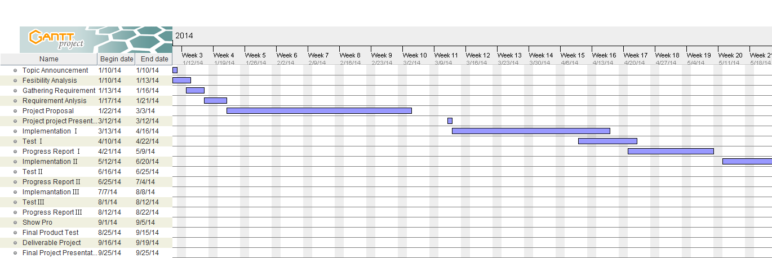

Figure 3: Overview (1) (Tentatively from mid-January to late September)

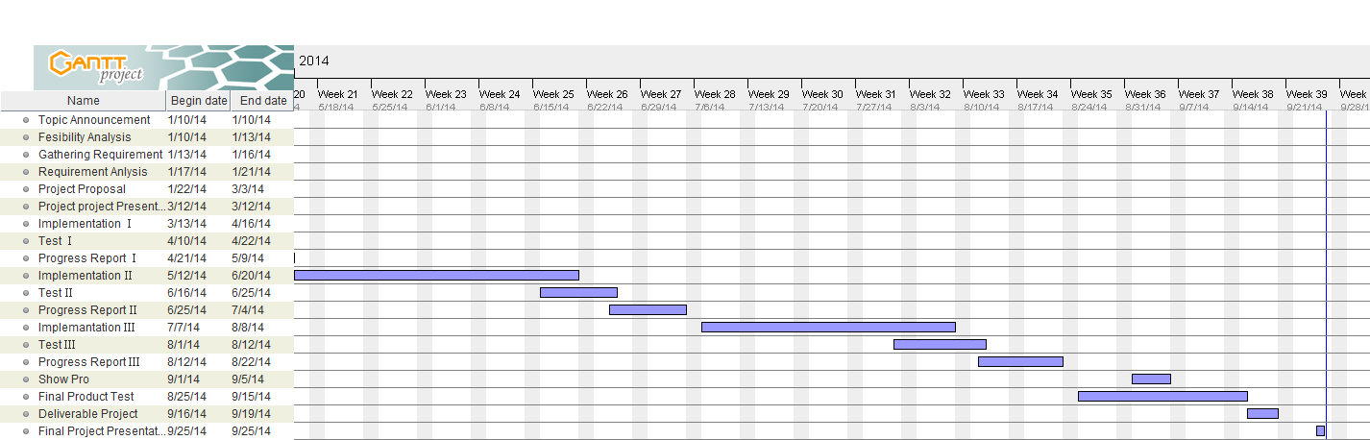
Figure 4: Overview (2) (Tentatively from mid-January to late September)

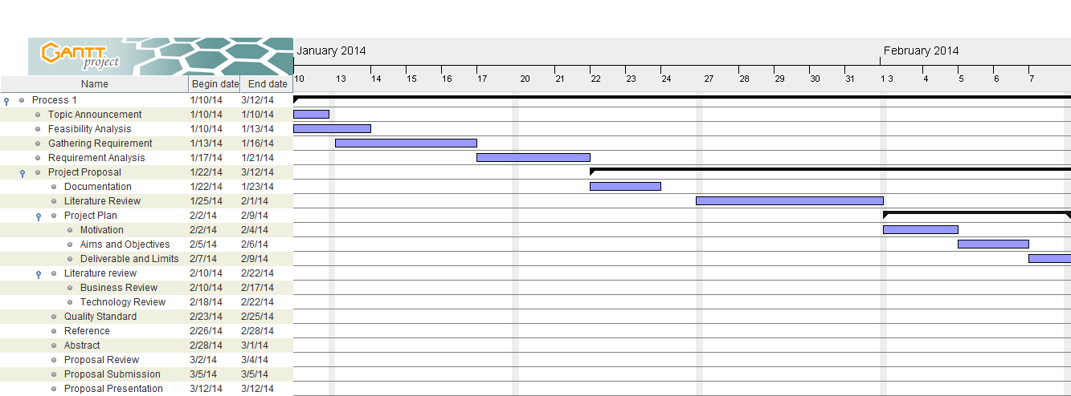

Figure 5: Proposal period milestone (1) (Tentatively from mid-January to mid-March)

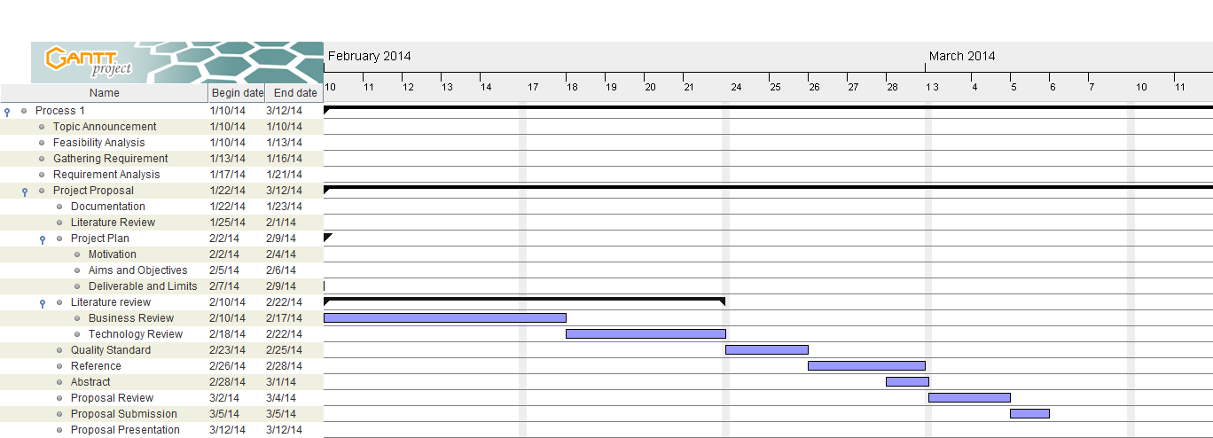

Figure 6: Proposal period milestone (2) (Tentatively from mid-January to mid-March)

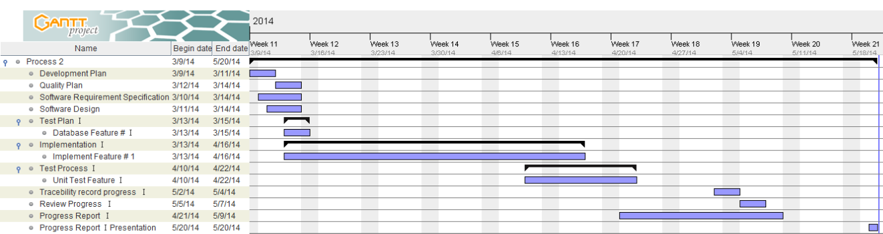

Figure 7: ProgressⅠ period milestone (Tentatively from mid-March to late May)

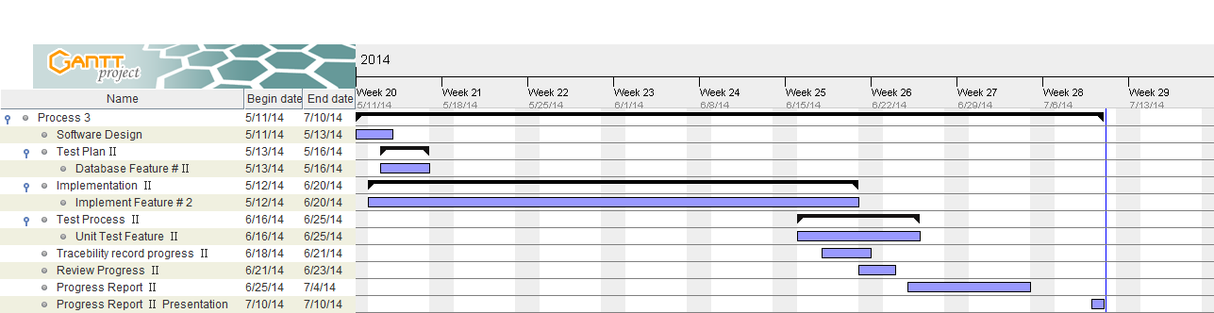

Figure 8: ProgressⅡ period milestone (Tentatively from mid-May to mid-July)

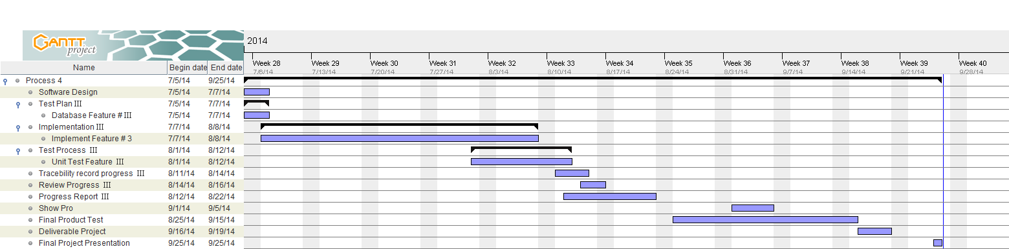

Figure 9: Progress Ⅲ period milestone (Tentatively from mid-July to late September)

Chapter Six | Software Configuration Management

6.1 Software Configuration Management
Software Configuration Management can coordinate the software management, which can minimize the confusion in the development. It is a set of activities designed to control changes by identifying the parts of the development that is likely to be changed, establishing relationships among them, defining mechanisms for managing different versions of them, controlling the changes imposed, and auditing and reporting on the changes made. In a word, Software Configuration Management is a methodology to control and manage a software development with its configuration. It can determine what to change and who to be responsible for the change when something goes wrong.

6.2 Filename Format
For the filename format that we use for all project documents is:
Scan in Travel_ [Document name] _V [Version].file type

6.3 Change Management
Change Management manages all the changes in the software development of the project. All the change requests will be recorded in the Change Request Document. We use the strategy for change management as following steps:
- Analyzing the change.
- Designing the change plan.
- Requesting for the change.
- Approving the change request by project advisor.
- Implementing the change as the approved change request.

6.4 Software Configuration Item Table
No. | Item | Filename | File Type | Owner | Path | Baseline Version
1 | Project Proposal | Scan in Travel_Proposal_V 1.1 | .doc | Yirui Wang  Ruijuan Liu | Scan in Travel /Proposal | 1.1
2 | Project Plan | Scan in Travel_Project Plan_V 1.0 | .doc | Yirui Wang  Ruijuan Liu | Scan in Travel /Project Plan | 1.0
3 | Software Requirement Specification | Scan in Travel_Software Requirement Specification _V 1.0 | .doc | Yirui Wang  Ruijuan Liu | Scan in Travel /Software Requirement Specification | 1.0
4 | Software Design | Scan in Travel_Software Design _V 1.0 | .doc | Yirui Wang  Ruijuan Liu | Scan in Travel /Software Design | 1.0
5 | Test Plan | Scan in Travel_Test Plan _V 1.0 | .doc | Yirui Wang  Ruijuan Liu | Scan in Travel /Test Plan | 1.0
6 | Test Record | Scan in Travel_Test Record _V 1.0 | .doc | Yirui Wang  Ruijuan Liu | Scan in Travel /Test Record | 1.0
7 | Traceability Record | Scan in Travel_Traceability Record _V 1.0 | .doc | Yirui Wang  Ruijuan Liu | Scan in Travel /Traceability Record | 1.0
8 | Executive Summary | Scan in Travel_Executive Summary _V 1.0 | .doc | Yirui Wang  Ruijuan Liu | Scan in Travel /Executive Summary | 1.0

Chapter Seven | Risk Management

7.1 Risk Management Process
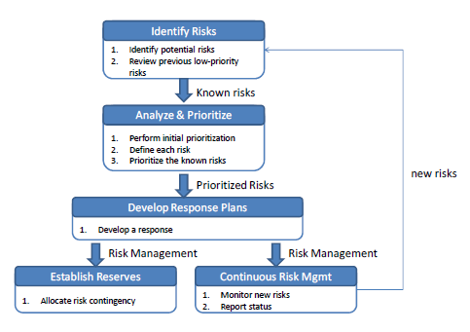
Figure 10: Risk Management Process Model

- Identify Risks: Identify project and business risks which have the potential of affecting the project and documenting the risk’s characteristics.
- Analyze and prioritize risks: Identify and assess the probability and impact of the risks.
- Develop response plans: Come up with plans which will minimize or avoid threats and maximize opportunities.
a. Accepting the risk
b. Avoid the risk
c. Contingency plans
d. Transfer the risk
e. Mitigate the risk

7.2 Risk Identification and Solutions

* H-high N-normal L-low

Technology failure

Risk ID | Headline | Description | Priority Level | Impact | Likelihood of Event | Mitigation Strategy
1 | Sever fail | Some factors lead to the situation where the server cannot provide accurate data. | N | Users may not be satisfied with the application. | Certainty | Exception Handling. Displaying proper messages for the users.

Human failure

Risk ID | Headline | Description | Priority Level | Impact | Likelihood of Event | Mitigation Strategy
2 | Lack of responsibility of team’s member | A member of the team cannot finish her own task on time, or cannot meet the requirement of project. | H | The project cannot be delivered in time. | Somewhat likely | Report every team member’s work at project meetings, and discuss what should they finish before next meeting.
3 | Lack of skills | A member of the team does not have experience and skill to do the project. In order to find/create certain functions, developers take longer time since they need to gather knowledge first. | H | It may lead to the situation where the project cannot finish in time. | Certainty | Practice and training.
4 | A team member gets sick or has an accident | A team member may get sick or has an accident, and cannot work on the project. | L | It may leads to the situation where the project cannot finish in time. | Somewhat likely | · Adjust the plans and schedules.  · The absent member should assign works to the other member who can continue work on the project.

Process failure

Risk ID | Headline | Description | Priority Level | Impact | Likelihood of Event | Mitigation Strategy
5 | Project schedule changes. | Some factors may force the project schedule to change. | H | Influence progress | Certainty | Create comprehensive project timeline and adjust the project schedule according to the requirements.
6 | The system faces reliability or stability issues. | Users cannot use the application or cannot get complete information because of unexpected external factors. | N | Users may not be satisfied with the application. | Somewhat likely | Manage the application and maintain the system timely.
7 | Requirements might change. | New ideas from stakeholders make the project requirements change. | H | Affect the process of the application development. | Certainty | · Before developing each function, understand the needs as much as possible.  · Meet and discuss with other stakeholders.
8 | Tasks are not completed in time. | Some factors may leads to the situation where the team members cannot finish their work in time. | N | Influence progress, and affect the delivery time. | Somewhat likely | · In project planning, team members should reserve buffer time.  · Meet with team members and find solutions.
9 | Work cannot be traced. | The change of the requirement may leads us to change our previous work. | H | Spend a lot of time to trace back the changes. | Somewhat likely | Create the traceability record.
10 | Works do not meet the requirements. | Team members did not understood the requirement clearly. | L | · Spend a lot of time to change.  · Cannot deliver the project in time. | Somewhat likely | Have a frequent meeting and share members’ understanding of the requirements.

Chapter Eight | Reference

[1] Definition of project plan
http://en.wikipedia.org/wiki

[2] Definition of risk management
http://energy.gov/sites/prod/files/cioprod/documents/Risk_Management.pdf

[3] Definition of traceability
http://en.wikipedia.org/wiki

[4] Definition of unit test
http://en.wikipedia.org/wiki

[5] Definition of configuration item
http://www.businessdictionary.com/definition/configuration-item.html

[6] ADT Plugin for Eclipse
http://developer.android.com/intl/zh-cn/tools/sdk/eclipse-adt.html

